SEND Policy

Mugginton Church of England
Primary School

Reviewed | 6th October 2021
HT | J Green
CoG | C Stroud
Future Review | Autumn 2022

Special Educational Needs and Disabilities Policy
Introduction
At Mugginton Church of England Primary School we are determined to provide a rich curriculum and the very best support and guidance for all of our pupils. We encourage our pupils to be respectful, to treat others as they would like to be treated and to be the best person they can be.
This policy has been written in accordance with the Christian ethos of our school, our recognition of British values, an awareness of our position in the Global community and taking account of all current Safeguarding and Child Protection guidance. The policy was written by: Mrs Emma Dennis (SENCO) in consultation with: Mr Joseph Green (Headteacher), Mrs Catherine Stroud (SEND Governor) and all staff.

Legislation and Guidance
This policy complies with the statutory requirement laid out in the SEND Code of Practice 0-25 (2015) and has been written with reference to the following guidance and documents:
- SEND Code of Practice 0-25 (2015) SENCoP
- Special Educational Needs and Disability Regulations (2014) SEND Regs
- Equality Act 2010: advice for schools DfE Feb 2013 Equality Act
- Schools SEN Information Report Regulations (2014)
- Statutory Guidance on Supporting Pupils with Medical Conditions (2014) Medical Conditions Guidance
- Teachers’ Standards (2013) Teachers' Standards
- The National Curriculum in England Key Stage 1 and 2 Framework Document (2013) NC 2013
- Safeguarding Policy
- Accessibility Plan.

Aims
Our Special Educational Needs and Disabilities Policy aims to set out how Mugginton Church of England Primary School will support and make provision for pupils with special educational needs (SEN) and disabilities. It will explain the roles and responsibilities of everyone involved in providing for pupils with SEN.

At Mugginton Church of England Primary School we have high aspirations for all our pupils. We focus on improving outcomes for children with SEN and/or disabilities to enable them to reach their full potential and make successful transitions to high school and into adult life. As a small school we all take responsibility for ensuring that all children have access to a broad and balanced curriculum. We work in partnership with our families, ensuring that children and their parents and carers are fully involved in decision making. We nurture our pupils, encouraging them to have high expectations of themselves, building confidence and high self-esteem. We strive to give our children the curriculum and experiences they need in order to be lifelong learners who are curious, creative, respectful and sensitive towards the needs of others.

Objectives

- To work within the SEND Code of Practice (2015) ensuring that all staff are responsible for the progress of all of our children. Every teacher is a teacher of every child or young person including those with special educational needs or disabilities. To provide support, advice and training for all staff working with pupils with SEN and disabilities.
- To ensure that every child can access a broad and balanced curriculum through high quality teaching which is differentiated and adapted to remove any barriers to learning.
- To encourage all pupils to participate in wider school life, developing high self-esteem, resilience and independence.
- To work closely with children, parents, staff and external agencies in order to provide the individual support that each child needs in order to reach their full potential.
- To adopt a graduated approach when providing support: assess, plan, do, review. We aim to identify SEN as early as possible in order to provide the best outcomes for our children. Once individual needs are identified we plan high quality interventions for individuals and groups to close gaps and maximise learning. Interventions are regularly reviewed and adjusted where necessary.

Roles and Responsibilities

The SENCO will
- Work with Mr Joseph Green (Headteacher) and Mrs Catherine Stroud (SEND Governor) to determine the strategic development of the SEND policy and provision in the school.
- Have day-to-day responsibility for the operation of this SEND policy and the co-ordination of specific provision made to support individual pupils with SEN and disabilities, including those who have EHC plans.
- Provide professional guidance to colleagues and work with staff, parents, and other agencies to ensure that pupils with SEN and disabilities receive appropriate support and high quality teaching.
- Advise on the graduated approach to providing SEN support.
- Advise on the deployment of the school’s delegated budget and other resources to meet pupils’ needs effectively.
- Be the point of contact for external agencies, especially the local authority and its support services.
- Liaise with potential next providers of education to ensure that the school meets its responsibilities under the Equality Act 2010 with regard to reasonable adjustments and access arrangements.
- Ensure the school keeps the records of all pupils with SEN up to date.
The SEND Governor will:
- Help to raise awareness of SEN issues at meetings of the Governing Body.
- Monitor the quality and effectiveness of SEN and disability provision within the school and update the governors.
- Work with the Headteacher and SENCO to determine the strategic development of the SEND policy and provision in the school.
The Headteacher will:
- Work with the SENCO and SEND Governor to determine the strategic development of the SEND policy and provision within the school.
- Have overall responsibility for the provision and progress of learners with SEN and disabilities.
The Class Teacher is responsible for:
- The progress and development of every pupil in their class.
- Working closely with any teaching assistants or specialist staff to plan and assess the impact of support and interventions and how they can be linked to classroom teaching.
- Working with the SENCO to review each pupil’s progress and development and decide on any changes to provision.
- Ensuring they follow this SEND policy.

Defining SEN

The SEND Code of Practice 0-25 (2015) presents the following definition of SEN:

‘A child or young person has SEN if they have a learning difficulty or disability which calls for special educational provision to be made for him or her.

A child of compulsory school age or a young person has a learning difficulty or disability if he or she:
- has a significantly greater difficulty in learning than the majority of others of the same age, or
- has a disability which prevents or hinders him or her from making use of facilities of a kind generally provided for others of the same age in mainstream schools or mainstream post-16 institutions.’
(Introduction p15 paragraphs xii and xiv)

The SEND Code of Practice 0-25 (2015) identifies the four ‘Broad Areas of Need’

Communication and interaction

Children and young people with speech, language and communication needs (SLCN) have difficulty in communicating with others. This may be because they have difficulty saying what they want to, understanding what is being said to them or they do not understand or use social rules of communication. The profile for every child with SLCN is different and their needs may change over time. They may have difficulty with one, some or all of the different aspects of speech, language or social communication at different times of their lives.
Children and young people with ASD, including Asperger’s Syndrome and Autism, are likely to have particular difficulties with social interaction. They may also experience difficulties with language, communication and imagination, which can impact on how they relate to others.

Cognition and learning

Support for learning difficulties may be required when children and young people learn at a slower pace than their peers, even with appropriate differentiation. Learning difficulties cover a wide range of needs, including moderate learning difficulties (MLD), severe learning difficulties (SLD), where children are likely to need support in all areas of the curriculum and associated difficulties with mobility and communication, through to profound and multiple learning difficulties (PMLD), where
children are likely to have severe and complex learning difficulties as well as a physical disability or sensory impairment. Specific learning difficulties (SpLD), affect one or more specific aspects of learning. This encompasses a range of conditions such as dyslexia, dyscalculia and dyspraxia.

Social, emotional and mental health difficulties

Children and young people may experience a wide range of social and emotional difficulties which manifest themselves in many ways. These may include becoming withdrawn or isolated, as well as displaying challenging, disruptive or disturbing behaviour. Other children and young people may have disorders such as attention deficit disorder (ADD), attention deficit hyperactive disorder (ADHD) or attachment disorder (AD).

Sensory and/or physical needs

Some children and young people require special educational provision because they have a disability which prevents or hinders them from making use of the educational facilities generally provided. It is important to note that these difficulties can be age related and may fluctuate over time. Children and young people with vision impairment (VI), hearing impairment (HI) or a multi-sensory impairment (MSI) may require additional support in order to access the school facilities and curriculum.

At Mugginton Church of England Primary School we recognise that some children will have one or more of these needs and will use a combination of measures to assess needs. The purpose of identification is to work out what actions we can take to support our pupils, not to fit them into a category. Every child at Mugginton Church of England Primary School is unique and we will: listen to the voices of the child and his/her parents; speak to all staff working with the child; use internal tracking/assessment data; and seek advice from outside agencies, where appropriate, in order to find the best approach for each individual.

We will also consider what is not SEN but may impact on progress and attainment. This would include: disability (which alone does not constitute SEN), attendance and punctuality, health and welfare, children in receipt of Pupil Premium grants, children with EAL, Looked After Children (LAC) and children of servicemen/women.

Admission arrangements

The admissions arrangements for all pupils at Mugginton Church of England Primary School are in accordance with national legislation, including the Equality Act 2010. This includes children with any level of SEN; those with an EHC plan and those without.
Identifying pupils with SEN and assessing their needs using a graduated approach
We follow the graduated approach and the four-part cycle of assess, plan, do, review. (APDR) as set out in the following diagram:
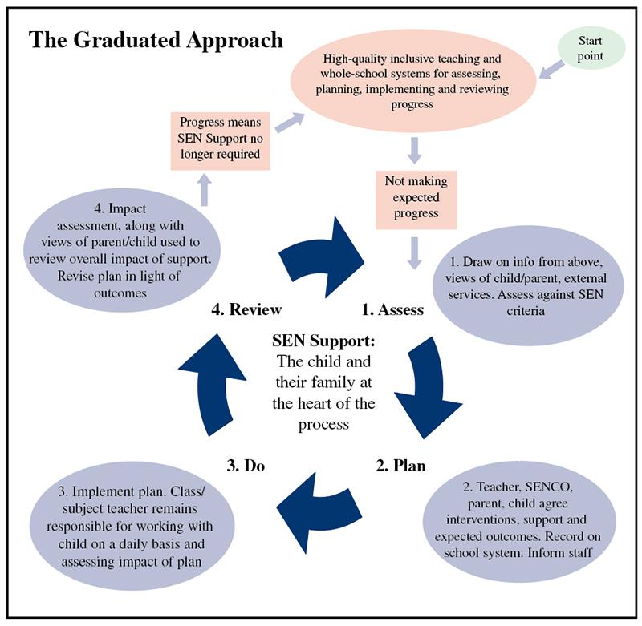
Diagram from: Packer, N. (2017). The Teacher's Guide to SEN. United Kingdom: Crown House Publishing.

Assess
At Mugginton Church of England Primary School we believe that early identification and intervention are crucial in supporting our pupils effectively. We will ensure that all staff are alert to emerging difficulties, listen to the concerns of children and parents and liaise with the SENCO in order to support children with SEN.
We will assess each pupil’s current skills and levels of attainment on entry, which will build on previous settings and Key Stages, where appropriate. Class teachers will make regular assessments of progress for all pupils and identify those whose progress:
- Is significantly slower than that of their peers starting from the same baseline.
- Fails to match or better the child’s previous rate of progress.
- Fails to close the attainment gap between the child and their peers.
- Widens the attainment gap.
This may include progress in areas other than attainment, for example, social needs.
The progress of all pupils will be discussed on a termly basis at Pupil Progress Meetings. Assessment can be made through observations, work scrutiny, discussion with the child and with key adults, test data, specialist observation and externally validated such as the ‘British Picture Vocabulary Scale’ (BPVS).
Slow progress and low attainment will not automatically mean a pupil is recorded as having SEN.
When deciding whether special educational provision is required, we will start with the desired outcomes, including the expected progress and attainment, and the views and the wishes of the pupil and their parents. We will use this to determine the support that is needed and whether we can provide it by adapting our core offer, or whether something different or additional is needed.
Plan

Planning will involve consultation between the teacher, SENCO, parents and pupil to agree on the
adjustments, interventions and support that are required; the impact on progress, development and
or behaviour that is expected and a clear date for review. Parental involvement may be sought,
where appropriate, to reinforce or contribute to progress at home. All those working with the pupil, including support staff, will be informed of their individual needs, the support that is being provided, any particular teaching strategies/approaches that are being employed and the outcomes that are being sought. If required, a child may have an Individual Education Plan (IEP) which will detail small, achievable and measurable targets to work on.

Do

The class teacher remains responsible for working with the child on a day-to-day basis. They will
retain responsibility even where the interventions may involve group or one-to-one teaching away
from the main class. They will work closely with the SENCO, teaching assistants and /or relevant specialist staff to plan and assess the impact of support and interventions and links with classroom teaching.

Review

Reviews will be undertaken in line with agreed dates. The review process will evaluate the impact
and quality of support and interventions. It will also take account of the views of the pupil and their
parents. The class teacher, in conjunction with the SENCO, will revise the support and outcomes
based on the pupil's progress and development making any necessary amendments, in consultation with parents and the pupil. Parents will be provided with clear information about the impact of support to enable them to be involved in planning the next steps.

Parent and Pupil ‘Voice’
Mugginton Church of England Primary School is a small school and this allows us to build positive relationships with families as we are in regular contact with our parents and carers. We will have an early discussion with parents/carers to discuss a child’s areas of strength and difficulty. It is important that we listen to the views of parents as they know their child best of all. We will notify parents/carers of the SEN support their child is receiving, including whether or not they need to be placed on our SEN register.
We also value the right of the child to be involved in making decisions about the support they need and exercising choice in how they are supported. We encourage all pupils to take responsibility for their own learning and therefore we gather their views at all stages of the APDR cycle.
GRIP Funding and EHC Plans

A child with more significant SEN may require specialist support. Derbyshire’s ‘Graduated Response to Individual Pupils’ (GRIP) offers additional SEND funding and support to schools.

A child that requires more support than is available through school SEN support can have an application for an Education, Health and Care Plan (EHCP) made for them. This may be requested by the school, the parent, health or social care. Applications are made through the Local Authority when a child requires a multi-agency approach to assessing their needs and planning provision. Information will be gathered from parents, teachers, the SENCO and other professionals (e.g. health and social care). Parents have the right to appeal against a decision made by the Education, Health and Care panel.

Further information about the processes involved in applying for GRIP funding and EHC Plans can be found here:
Derbyshire GRIP: https://localoffer.derbyshire.gov.uk/#!/model/page/20/5298
Derbyshire EHCP: https://localoffer.derbyshire.gov.uk/#!/model/page/information/5326
Derby City: https://www.derby.gov.uk/education-and-learning/derbys-send-local-offer/ehc-assessments-plans/
Other Agencies
At Mugginton Church of England Primary School we work with the following agencies to provide support for our pupils.
- Educational Psychologist - Dr Fatima Bignell
- Derbyshire SSSEN
- Child and Adult Mental Health Services (CAMHS)
- Multi Agency Teams (MAT)
- Family Support Workers
- Occupational Therapists and Physiotherapists
- Sensory and Physical Support Service
- Speech Therapy
- Autism Outreach
- Behaviour Support Service
Transition
We work with a number of local high schools to ensure that all children have a smooth transition to the next phase of their education. ‘Transition’ or ‘taster’ days are arranged for all pupils in their final year at Mugginton Church of England Primary School. Children with SEN and/or disabilities can receive additional support during these transitions. They may be offered extra ‘transition’ or ‘taster’ days; given extra visual reminders of their new school (e.g. timetables, school plans/maps); and meet with the SENCO from their new school.
Staff Development
We aim to keep all school staff up to date with relevant training and developments in teaching practice in relation to the needs of pupils with SEN and disabilities. The SENCO attends relevant SEN courses, SEN meetings and facilitates and signposts relevant SEN focused external training opportunities for all staff. We recognise the need to train all our staff on SEN issues and we have funding available to support this professional development. The SENCO, with the Headteacher and Governing Body, ensures that training opportunities are matched to school development priorities. Teachers are expected to keep abreast their knowledge and understanding of: dyslexia; communication and language difficulties; autism; and social, emotional and behavioural difficulties.
Monitoring and Evaluating SEN

At Mugginton Church of England Primary School we are committed to ensuring that we encourage and support every child to reach their full potential. In order to continually improve our practice, it is important to gather regular feedback about our SEND provision. We do this in a number of ways e.g. school council, parents’ meetings, parents’ evenings, staff feedback, questionnaires, meeting with the SEND governor. The SENCO will also closely monitor all progress and attainment data and the provision map.

Storing and Managing Information

All records containing sensitive information relating to SEN and disabilities will be treated as confidential and stored in a locked cabinet when not in use. Information shared with outside agencies by telephone, email or letter will also be treated as confidential. Please view the school policy relating to Data Protection for further information.
Resolving Disagreements
Concerns regarding SEN provision should first be discussed with the class teacher who will listen and address them where appropriate. If it is felt that the issues have not been resolved, an appointment should be made with Mrs Emma Dennis (SENCO) or Mr Joseph Green (Headteacher).
Our Complaints Policy can be found on the school website: https://www.muggintonschool.co.uk/OfficialBits/OfficialBits.html
Review of Policy
This policy will be reviewed by Mrs Emma Dennis every year. It will also be updated if any changes to the information are made during the year. It will then be approved by the Governing Body.
Further Information

The SENCO, Mrs Emma Dennis can be contacted on 01335 360 261
This SEND Policy is closely linked to other policies and documents. These can be found on our school website https://www.muggintonschool.co.uk/

- SEN Information Report - Special Educational Needs and Disabilities Provision Offer
- Child Protection and Safeguarding Policy
- Data Protection Policies
- Accessibility Plan
- Behaviour Policy
- Anti-Bullying Policy
- Children with Medical Needs Policy
- Equality Policy
- Looked After Children Policy
- Mental Health Policy

