Welcome to our Church School  This leaflet has been prepared to help you to understand the measures we have in place to keep our children safe and happy.  Every visitor is asked to sign our visitors book in the office and to sign out at the end of your visit.  Full copies of our Safeguarding, Health and Safety and our Whistleblowing Policies are available on the ‘Official Information’ page of the school website. Hard copies are available from the office.  Mugginton Church of England Primary Schools operates a strict no-smoking policy. This includes all of the school grounds as well as the buildings | Mugginton Church of England Primary School  Headteacher: Mr Joseph Green  Telephone: 01335 360261  If you have any concerns about a child, please report it to staff immediately.  Our Designated Safeguarding Lead is Mr Joseph Green or Mrs Dennis or Mrs Wallen when Mr Green is not available.  Should these staff members be unavailable, please speak with Mrs Horobin who can take advice from the Starting Point helpline and inform Mr Green.  Our governor with responsibility for Safeguarding is our Chair of Governors: Mrs Catherine Stroud.  - Keeping children safe is our most important responsibility – we believe that safeguarding children is everyone’s responsibility.  REMEMBER: if in doubt, ask Please do not leave our school without telling someone or doing something. | Mugginton Church of England Primary School  - Staying Safe at Mugginton  - Keeping children safe is our most important responsibility – we believe that safeguarding children is everyone’s responsibility.  An information leaflet for visitors
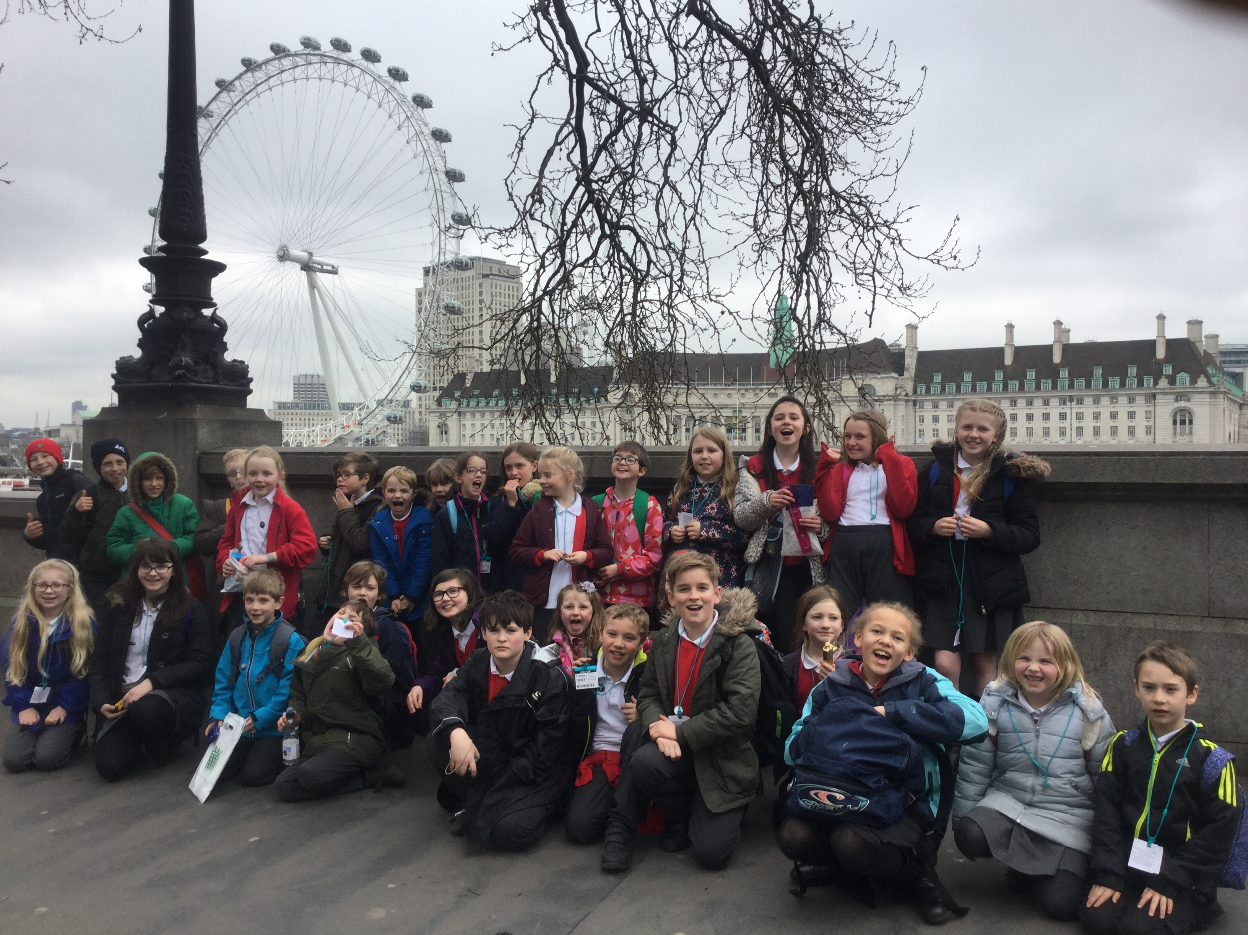Safeguarding Procedure  Our school culture places safeguarding and the welfare of children at its heart. We work together as a school community to keep children safe and share any concerns about a child’s wellbeing, however small they may appear.  If you are concerned about a child’s welfare, please speak directly to the Designated Safeguarding Lead, Mr Joseph Green or, in his absence, Mrs Dennis or Mrs Wallen.  Full details will be recorded, including the date, time, child’s name, your name and a factual account of what has been seen or heard.  Please DO NOT conduct your own investigation – all concerns and information must be kept confidential. | Safeguarding Concerns  You might be concerned if:  - You see an injury  - Another person expresses a concern  - Something else you see or hear, inside or outside of school, raises a concern  - A pupil tells you something  If a child makes a disclosure to you:  - Reassure the child that they have done the right thing  - Listen, do not ask leading questions  - Do not promise confidentiality  - Try to record notes including the date and time and pass on your concerns to the Designated Safeguarding Lead as quickly as possible.  Your help and support of our most important job – the safeguarding of our children – is appreciated by all staff but most importantly by our wonderful children. | Allegations against staff or volunteers  Allegations about a staff member or volunteer should be made directly to the Headteacher, Mr Green. After discussing the allegation, guidance will be sought from the Local Area Designated Officer (LADO), Mr Miles Dent. If the allegation concerns the Headteacher, the Chair of Governors, Mrs Catherine Stroud should be informed by letter, marked ‘Confidential’ delivered via the school office.  Fire Precautions  In the event of the fire alarm sounding, everyone must evacuate the building immediately using the nearest fire exit. We assemble on the playground. Fire Drills are conducted each half term.  First Aid  Please contact a member of staff immediately in the event of an accident. A list of fully-trained first-aiders is available in the school office.  All accidents requiring first aid will be recorded using the school accident book. If your child has a medical condition, please let the office know.

