Mugginton Church of England Primary School
Children’s Peer on Peer Abuse & Bullying Policy

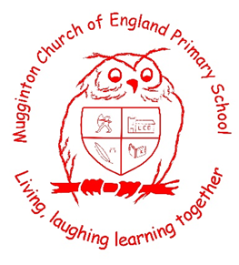

This Policy has been written by Archie, Daisy, Khloe and Brayden for all children in Years Five and Six, with input from Miss Beresford and Mr Green.

15th November 2021

Contents:

Feeling safe and happy at school

1. What is peer-on-peer abuse?
2. Bullying
3. Sending rude photos, messages or videos of yourself or other people
4. Harassment
5. Relationships
6. How do I know if someone is being abused?
7. What should I do if I am being abused?
8. What should I do if someone else is being abused?
9. Who can I talk to?
10. How can I help stop abuse from happening?
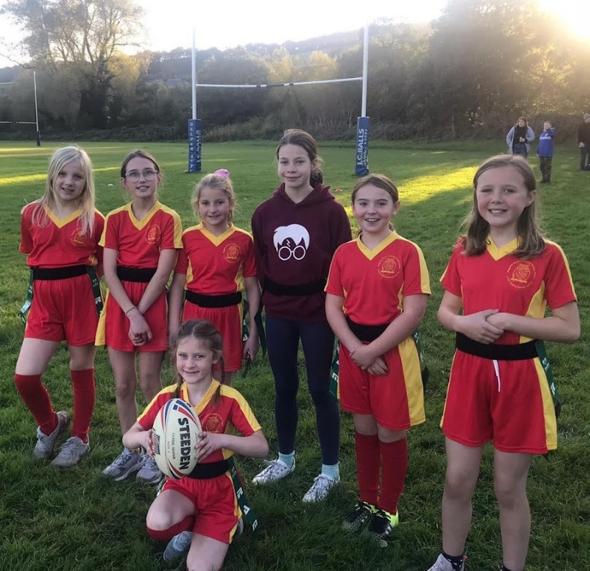
Feeling safe and happy at school
At Mighty Mugginton, we want to make sure that you feel looked after, safe and happy when you are in and out of school.
Sometimes we don’t know if something bad is happening, so you need to tell us because we want to help you feel safe and happy all the time.
This policy looks at peer-on-peer abuse and bullying, and what you can do when you feel you are being abused or bullied, or when you notice someone else being abused or bullied.
We can help you by:
• Teaching you what peer-on-peer abuse is.
• Teaching you what to do if you feel like you are being abused, or if someone else is being abused.
• Making sure you know the grown-ups you can speak to if you are worried.
- Giving all our Year Fives and Sixes a copy of this policy and putting it up on the display board by the office.
- Making sure you know you can always tell an adult in school if you are worried about anything.

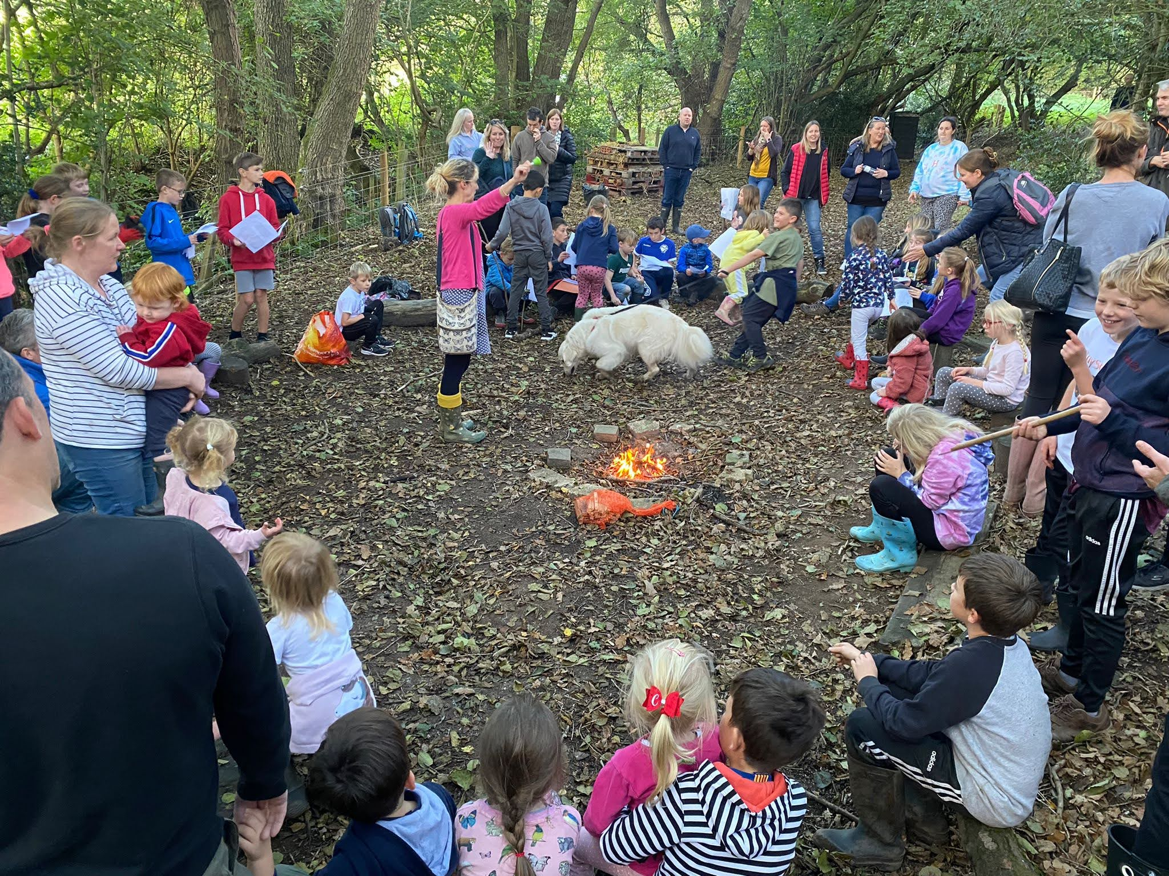
What is peer-on peer abuse and bullying?
A peer is someone who might be your friend, a child at school with you, or another child you may know.
Abuse is something which usually physically or emotionally hurts another person by using behaviour that is meant to scare, hurt or upset that person. Sometimes, it can be hard to know when abuse is happening, because not all abuse will hurt, scare or upset you, and you might not know it is happening. It’s really important you know when you are being abused so we can make sure it stops. There are lots of different types of abuse. It is important you know what these types of abuse are so you know what to do if you see them.
Verbal abuse means teasing someone or calling them names.
Physical abuse means tripping people up, pushing them or hurting them.
Emotional abuse means saying mean things and hurting people’s feelings.
Sexual abuse is when a child is forced or tricked into doing sexual things. It can happen in person or online and it is NEVER the child’s fault.

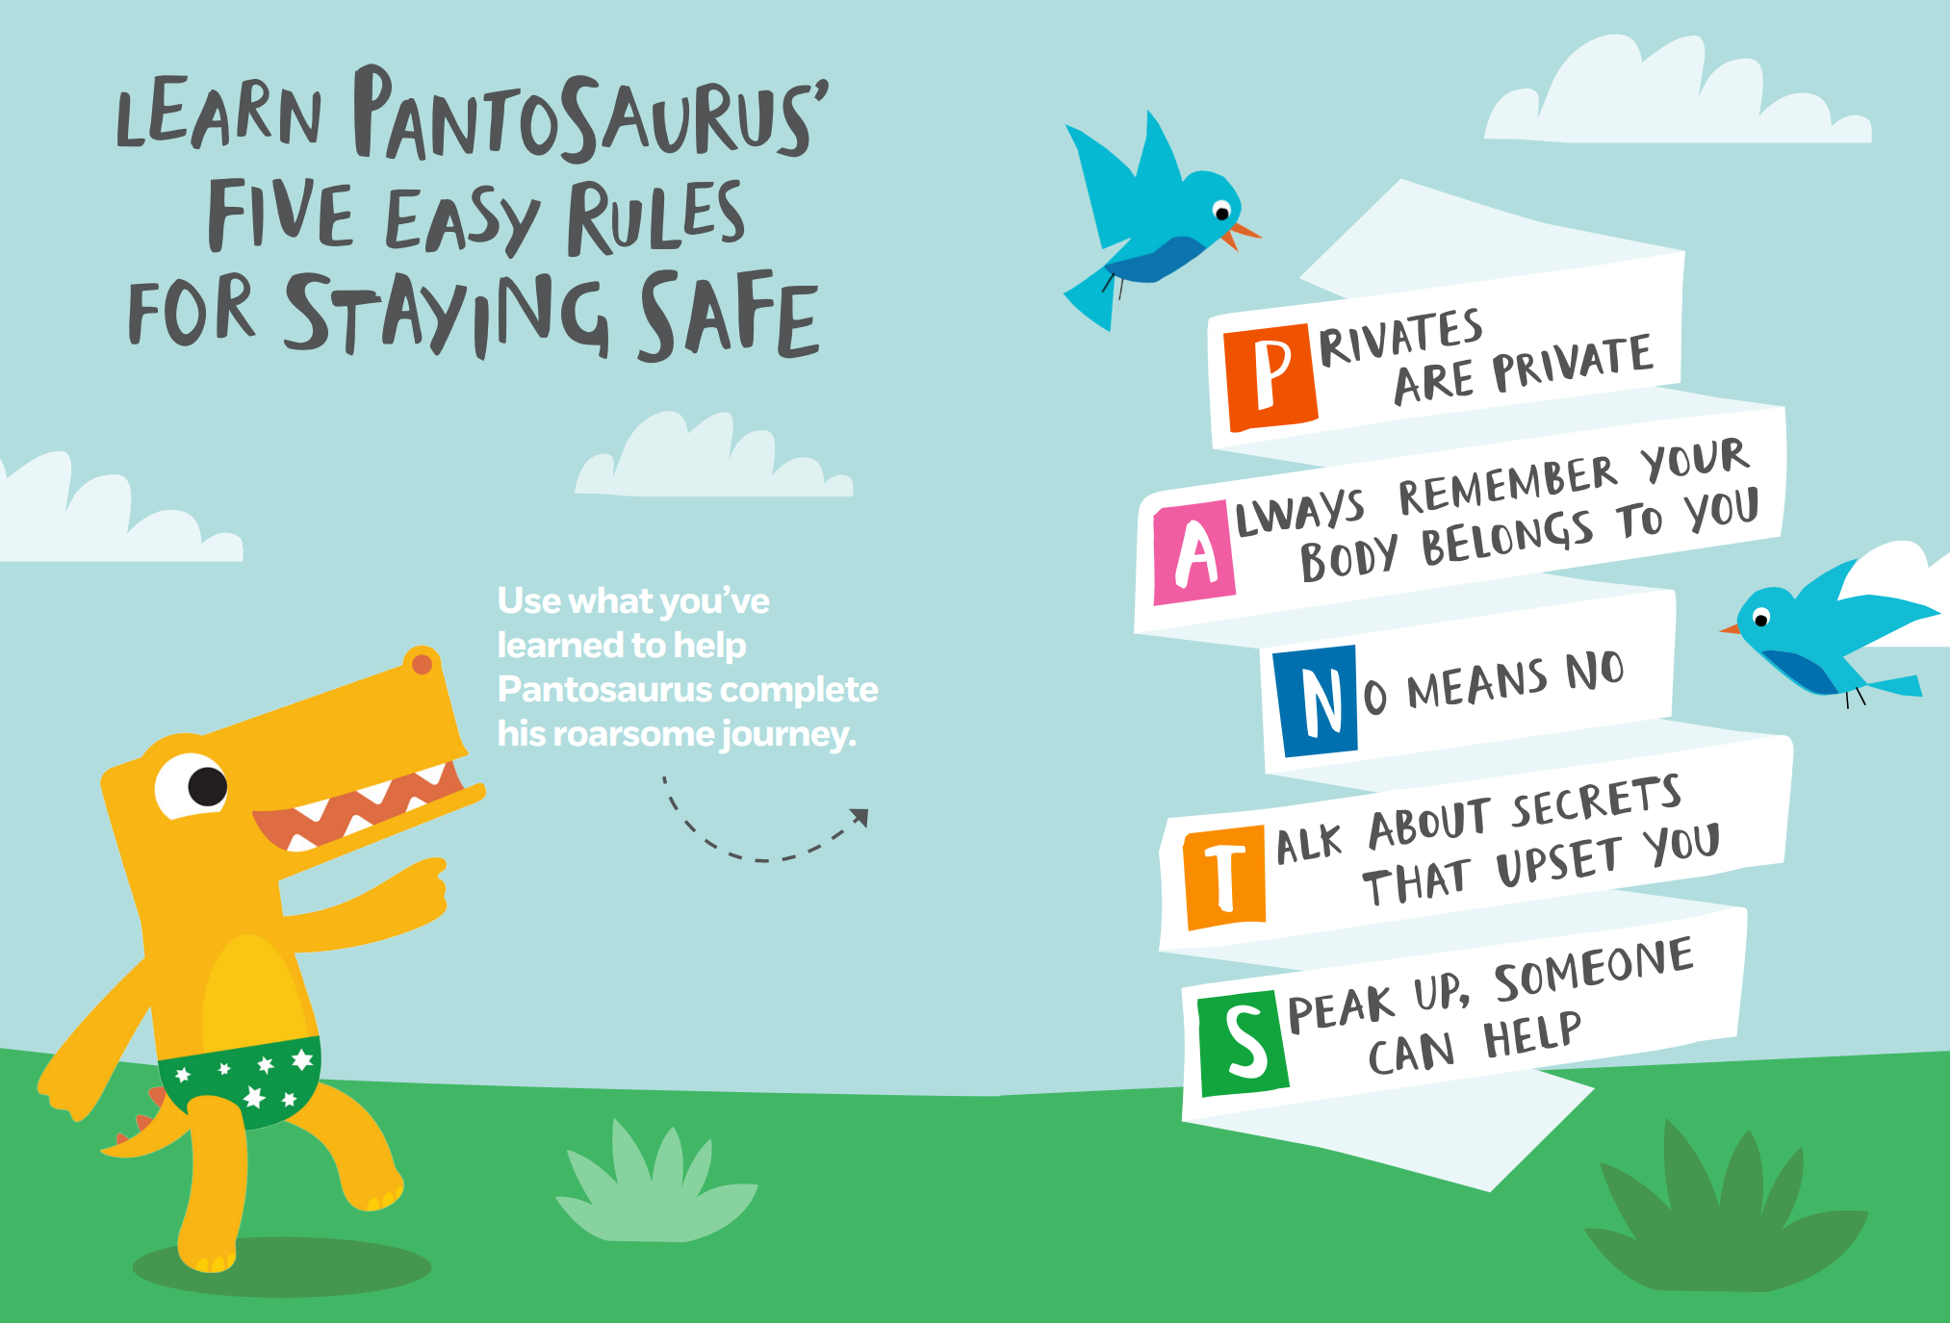

Our definition of bullying:
‘Bullying is when someone, adult or child, chooses to repeatedly pick on somebody and hurt them physically or mentally because of how they look, speak or act, even after they have been asked to stop.’
Bullying can be different things, and isn’t just hitting or kicking another person – it is directed at the same person and happens repeatedly.
Emotional bullying is hurting someone’s feelings, leaving them out or bossing them about.
Physical bullying is punching, kicking, spitting, hitting or pushing someone.
Verbal bullying is teasing someone, calling them names or using rude hand signs. People can also use verbal bullying to be racist or homophobic. Racist means bullying someone because of their skin colour, race or what they believe in. Homophobic means bullying someone because of their gender or sexuality; calling someone gay or lesbian to hurt their feelings would be homophobic. Sexist means bullying someone because of their sex (whether they are a boy or a girl).
Cyber bullying involves sending horrid messages over the internet or by text message. Bullying can be done through another person, by one person sending another person to say nasty things.
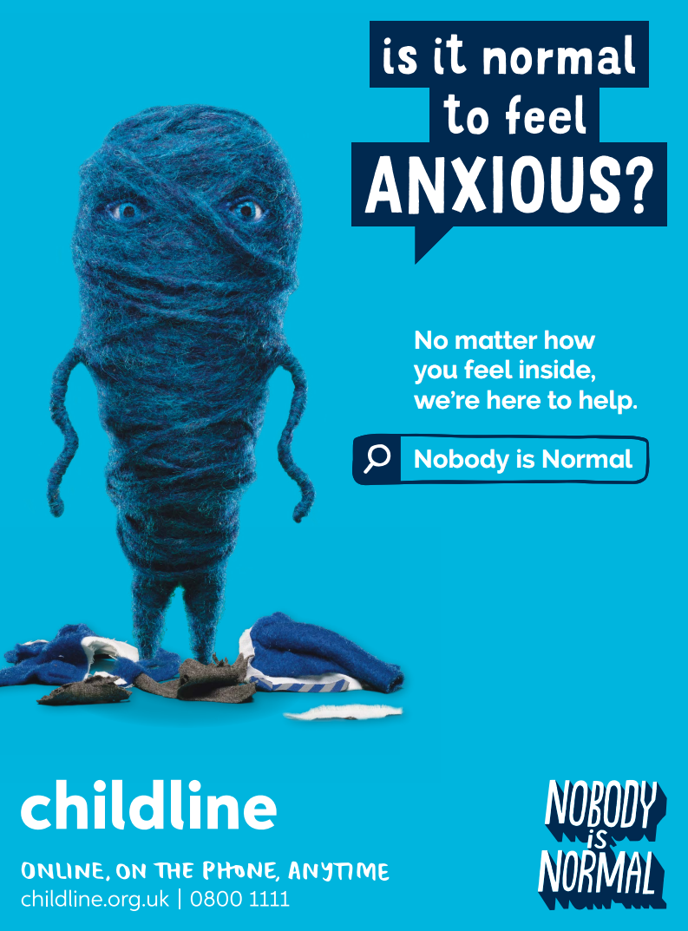
Sending inappropriate pictures, videos or messages
These can sometimes be called ‘nude pics’, ‘rude pics’ or ‘nude selfies’, but can also be rude messages. Pressuring someone into sending these pictures, videos and messages is abuse. Even if you are not the person who is sending them, it is illegal to have these kind of pictures or videos of a person if they are under 18 years old and it is also wrong to share them with anybody else.

If you are under the age of 18 don’t share inappropriate pictures, videos, or language. It can cause lots of upset and you can get in to serious trouble. If you are sent a picture talk to an adult like parents/carers or teachers about it. Never share inappropriate pictures with anybody else. Ask the adult what to do with it.

Harassment Sometimes, people can act sexually towards others and it might make them feel uncomfortable. This can happen online, on social media, through messages and face-to-face. It might make someone feel scared, embarrassed, uncomfortable or upset. It could be:
• Someone making rude comments, like telling rude stories, saying rude things about someone’s appearance or clothes.
• Calling someone names.
• Rude jokes or teasing.
• Being physical, like touching which makes you feel uncomfortable, messing with your clothes, or showing rude pictures or drawings.
• Being inappropriate online, like sharing private pictures and videos, or posting rude comments on social media.
• It might also be threats or pushing you to do something that you don’t want to do or aren’t ready for.
This is when someone makes you feel scared, embarrassed, uncomfortable, or upset. People could make you feel scared, act sexually towards you, or use you. Harassment can be calling people names, teasing them, and telling rude jokes that they may have seen online which make people feel uncomfortable. Could be making someone do something that they don’t feel comfortable doing. If you think you’re being harassed, tell the person that’s doing it to stop. You could tell a friend if you don’t feel comfortable telling an adult yourself. Or tell a teacher yourself.

Relationships Any relationship you have should be good and happy. A bad relationship might make someone feel scared, confused, worried and even unsafe. It’s really important that you know the difference between a good relationship and a bad relationship. Good relationships mean
• You are comfortable around that person.
• You can be honest with that person.
• You can say how you feel, what you are thinking and you listen to each other.
• You support each other and treat each other nicely.
• You feel safe.
• You trust that person.
• You’re equal – you don’t boss each other around or tell each other what to do.
• You feel looked after.
Bad relationships
• The person might push you, hit you or destroy your things.
• The person might tell you what to do, what to wear or who you can see.
• You might feel scared – they might say they will hurt you if you don’t do something. They might also say they will hurt you if you do something too.
• The person calls you names, makes you feel bad in front of other people and makes you feel bad about yourself.
• The person gets angry easily and you don’t know what will make them angry – it might make you feel nervous.
• The person might pressure you to do things you don’t want to do or aren’t ready for, which makes you feel uncomfortable.
• They might not take no for an answer if you say you don’t want to do something.
If you’re in a good relationship you should feel happy, comfortable and trust the person and they trust you. You don’t feel scared around them and you have respect for each other. You need to feel safe around them and that they will look after you.
If you’re in a bad relationship you will feel insecure, unsafe and scared. That person may push you or hurt you. Bad relationships are with people who are mean, talk rudely, are controlling and who talk behind your back. If you’re in a bad relationship, it is not your fault. You could stop interacting with them and ignore them, block them online and most importantly speak to a trusted adult.
How do I know if someone is being abused? It might be hard for you to know if you are being abused and you might not really understand it is happening. It is important you can recognise when behaviour isn’t appropriate. It’s also important that you can notice when someone else might be being abused. Some signs might be:
• Not going to school.
• Having injuries, like bruises.
• Feeling sad and down.
• Feeling like they can’t cope.
• Feeling withdrawn or shy.
• Getting headaches or stomach ache.
• Feeling nervous.
• Not being able to sleep, sleeping too much or getting nightmares.
• Feeling panicked.
• Using alcohol or drugs.
• Changing looks to look much older.
• Being abusive to someone else. Remember: you can feel all of these things too. Listen to how you feel, and know that these signs can mean you are being abused.
You can tell by looking at someone, they would be sad and upset, they will look tired as they will be worrying about the abuse they are struggling with, they might have bruises too.
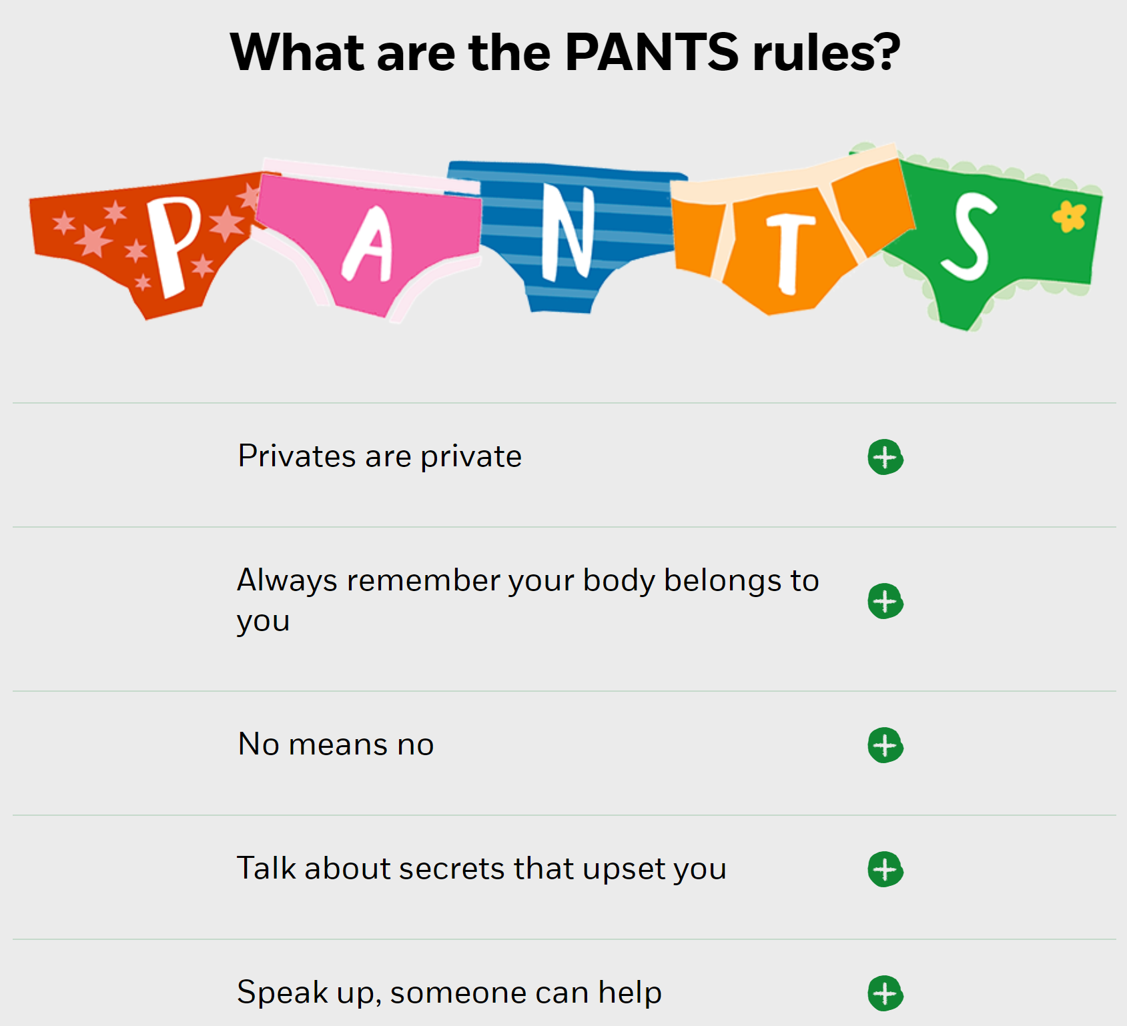
What do I do if someone else is being abused?
If you see someone else being abused, it is important that you help that person. You should never walk way and ignore the problem if you see someone else being abused, because the person might keep upsetting them. If you can, and it is safe to do so, tell the person abusing you to stop, but never get angry or hit them. Tell a grown-up, such as a teacher, as soon as you’ve seen someone being abused. Grown-ups can stop the abuse and make that person feel happy again. You should never feel scared to tell someone about abuse. Sometimes, you might not see someone being abused, but you might be worried about them. Or, you might think they are being abused by someone you don’t know, or someone they have told you about. It’s really important you tell someone even if you are worried, but haven’t seen any abuse.
Tell a teacher, as they will know what to do. Talk to the person being abused first to make sure that they are okay, and you know what is going on with them before you go to the teacher. Always tell a teacher even the person who you think is being abused says their fine as they could be lying because they’re scared of their abuser.

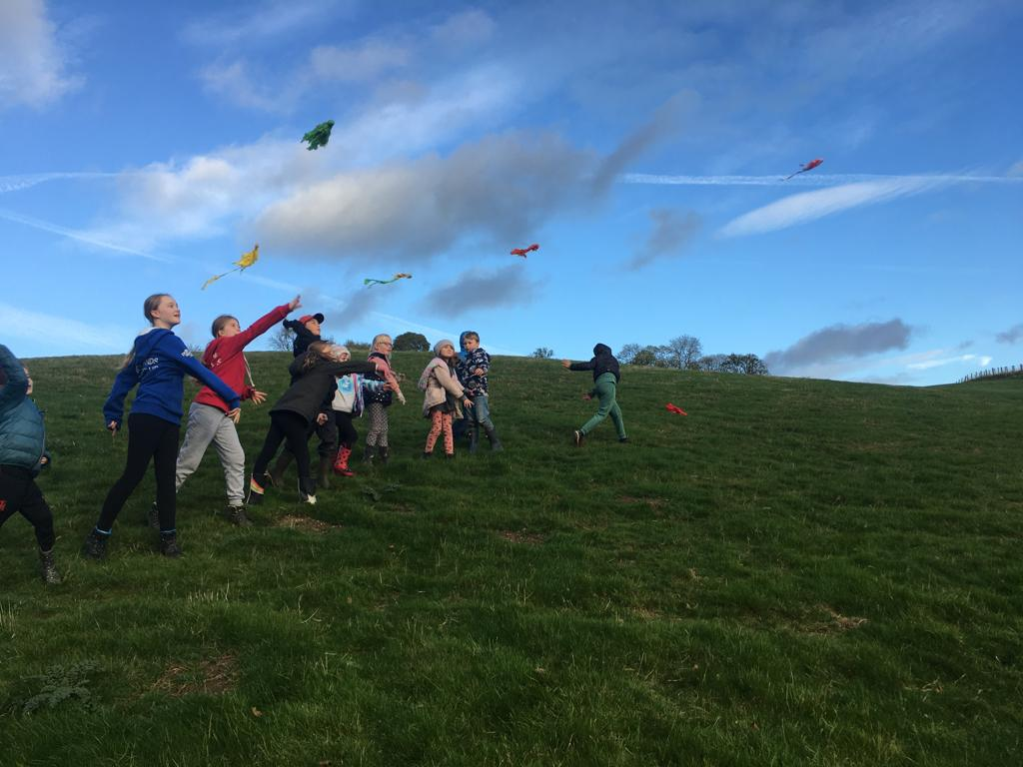

What to do if I am being abused?
Talk to a teacher or a trusted adult as soon you can and remember it is NEVER your fault. Talk to parents or carers, talk to your friends. Don’t try and fight back if you feel unsafe, tell someone instead and they will support you.
The first thing you should do is tell someone you trust. This could be a family member, a friend or any adult in our school. You can also tell the person abusing you to leave you alone. If telling them to leave you alone would make you feel too scared or worried that they might hurt you, make sure you tell someone so they can help.
You should try not to:
• Feel that you have done something wrong (you haven’t).
• Let what the person says or does upset you.
• Get angry or hit them. Always remember that if you are being abused, it is not your fault and you are never alone. You shouldn’t be scared to talk to someone if you are being abused. If you talk to a grown up, they can make the abuse stop.
- Feel there is no one to tell you. If you really feel you can’t talk to a teacher or family member, there are people like Childline who will help you.

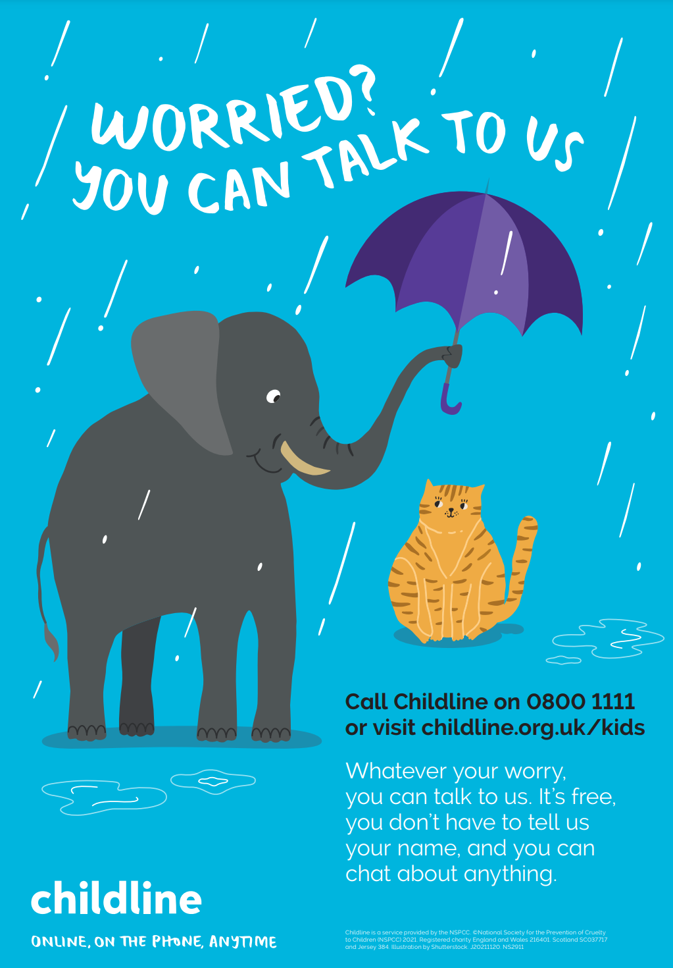
Who can I talk to?
Friends, Parents/Carers, Teachers. It is important you tell someone as soon as you are being abused, or you notice someone else being abused. Speaking to someone like your mum, dad, carer or teacher will mean that we can make sure the abuse stops and doesn’t happen again. The list below shows some of the grown-ups at our school that you can speak to:
Mr Green
Mrs Dennis
Mrs Wallen
Mr Beresford
Mrs Sweeney
Mr Wraith
Mr Dawson
Mrs Hardwick
Miss Beresford
Mrs Horobin
Miss Sutton
Mrs Birks
Mrs Pegg

How can I help stop abuse from happening? We can all help stop abuse at our school by:
• Making sure we understand how we should act towards others.
• Helping others when they are in need.
• Being kind, friendly and respectful to others.
• Thinking about people’s feelings before we say or do something.
• Taking part in school activities, like assemblies, PSHE lessons and circle time, which talk about peer-on-peer abuse.
• Talking to someone when we are worried. You should know that abuse is never OK and it is serious. It is not funny, or part of growing up. If you abuse someone, you will get into trouble. Let’s make Mighty Mugginton a happy place!

Tell someone to stop, make sure everyone knows what abuse is so that we know to stop if whilst it’s still in its early stages. We can tell trusted adults. We can be kind to everyone and make sure that everyone is safe and happy.

What our teachers will do to help you
We will take all things you tell us seriously and listen to you. We will write down what you tell us
We will be sensitive to your situation
We will not stop until the bullying/abuse has stopped
We will explain to children why bullying/abuse is wrong
We will try to make you feel right again. Remember it is never your fault
We might speak to your parents so they can help too
We will continue to monitor the situation afterwards and check that things have changed
We will continue to talk about anti-bullying/abuse at an age-appropriate level so everybody continues to feel safe and happy at school

If you are being bullied/abused at home or in school, remember:

START TELLING OTHER PEOPLE
